Volunteer Opportunities at Waterside Centre

Front of House Support
Overview: We are looking for warm and friendly volunteers to welcome our visitors to Waterside Centre.
Hours/days: Tuesdays – Saturdays, any time between the hours of 9am – 5pm
Commitment: Minimum of 1 hr per week, no maximum!
Where: Waterside Centre, Newbury
Overview of responsibilities:
- Greet our visitors as they come in and welcome them to Waterside Centre
- Offer an introduction to visitors when requested and/or appropriate to do so, including background information relating to the Waterside Centre (and its facilities and activities)
- Help with administrative tasks, such as answering the phone, handing out leaflets/guides, building checks and basic reception duties
- Answer questions or queries from visitors, such as directions, opening times etc and direct more complex questions to a member of staff, if necessary
- Supervise visitors in relation to health and safety and the rules of Waterside Centre. Raising minor issues with visitors directly and referring any escalating problems to a member of staff
- Assisting in the case of an emergency, such as a fire, and following the necessary procedures

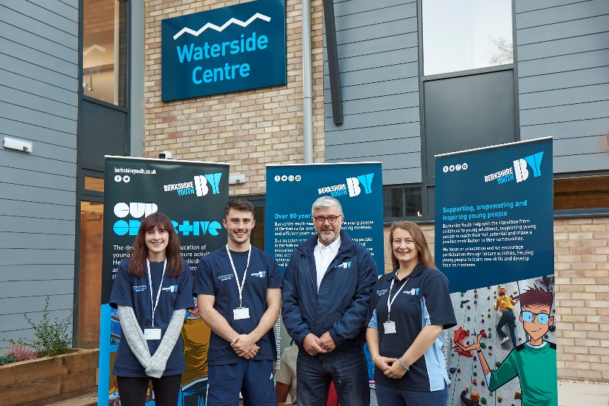

Community Larder Support
Overview: We are looking for volunteers to directly support the Waterside Community Larder, which empowers people in need with food and advice in a place where members feel they belong.
Hours/days: Tuesdays between the hours of 10am – 4pm
Commitment: Minimum of 1 hr per week, no maximum!
Where: Waterside Centre, Newbury
Overview of responsibilities:

Set up hall for food distribution
- Logging members on CRM
- Setting up new members on CRM
- Ensuring Health and Safety of volunteers
- Ensuring equitable distribution of food
- Connecting members with partner services
- Encouraging engagement from partner services
- Welcoming families and individuals to the Larder
- Support the raising of Community Larder profile
- Encourage new members to join
- Work within guidelines of Berkshire Youth policies and procedures
- Effectively complete monitoring and compliance paperwork

Youth Activity Support
Overview: We are looking for motivated individuals to support the youth work team delivering Youth Activities for Waterside Centre.
Hours/days: Mondays – Friday, any time between the hours of 9am – 7pm Commitment: Minimum of 1 hr per week, no maximum!
Where: Waterside Centre, Newbury
Overview of responsibilities:
- Greeting and registering participants as they arrive and leave the centre for their activities
- Supporting Youth Workers in delivering activities to participants, e.g. climbing, paddle, sports and arts and crafts
- Support the youth work team providing day to day support and advice to young people accessing Waterside Centre
- Actively engage and encourage young people’s participation in activities at Waterside Centre and in their community
- Setting up/packing down equipment, following procedure for Health and Safety
- Work within guidelines of Berkshire Youth policies and procedures

Waterside Centre, Waldegrave Place, Northbrook St, Newbury, RG14 1DS
T 01635 018500
E waterside@berkshireyouth.co.uk

