ONLINE EMPLOYABILITY COURSE
Roll on/off – with immediate start possible

Flexible delivery with 1:1 support at times to suit you

- Led by our friendly team
- Practical approach, with smiles and some fun
- Tips & tricks to look and feel more confident in interviews
- Work on your own progression plan
- Gain a qualification

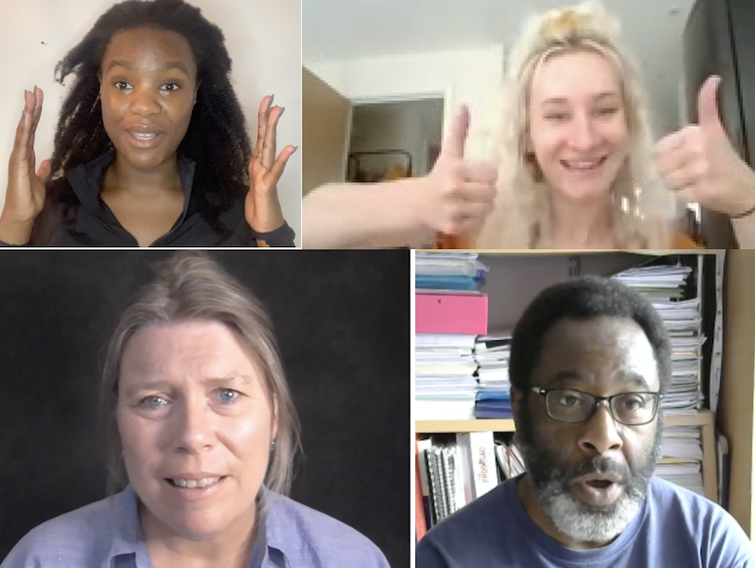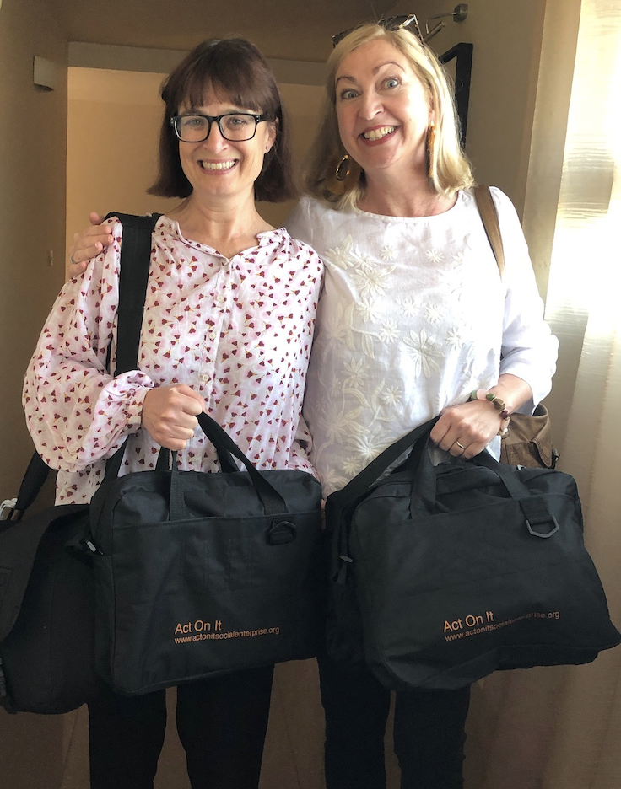

Contact Debbie at Act On It to book a quick chat and find out more

role.actonit@gmail.com
http://www.actonitsocialenterprise.org/contact

Places are free if you are economically inactive, unemployed or NEET

