Berkshire Youth, in partnership with Greenham Trust, can offer a FREE 6-WEEK PROGRAMME TO WEST BERKSHIRE PRIMARY SCHOOLS.
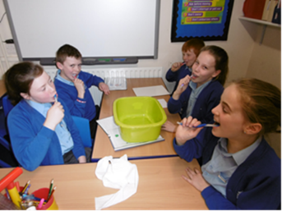
Fit 4 YOUth is a genuinely unique activities programme that is helping to keep Berkshire’s children and their families fit and healthy.
The project is committed to working to inspire children and their families to lead healthier lives by improving their diet, physical activity and hygiene, to better prepare themselves for their futures.
- “The programme covered a good range of the science and PSHE curriculum and revisited some of the curriculum covered in earlier years”
53% of overweight and obese children moved into a healthy weight category for their age and gender.

- “The ‘Taste Buds At The Ready’ activity had a big impact. Several children now bring fruit for a snack at break time and in their lunchboxes”
- “The ‘Shine Bright Like A Diamond’ activity was the children’s favourite. Many children commented on how dirty their teeth still were after brushing and that they were going to aim to clean their teeth better”
10.9% 86% tried a new fruit or vegetable

Working with children from Year 3 upwards, this opportunity is thanks to funding from Greenham Trust.

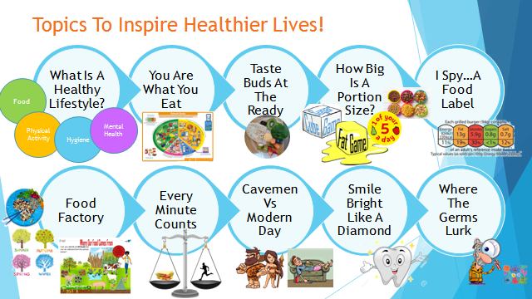
6 Week Programme
- 2 classes
- 1 hour per week with each class (within a two hour block e.g. 1-3pm)
- Start with ‘What Is A Healthy Lifestyle?’
- Choose 5 other topics
67.5%
Young People rated their enjoyment of Fit 4 Youth as 7+ out of 10.
67.5%
Young People rated their enjoyment of Fit 4 Youth as 7+ out of 10.
To book your 6-week course, or for more information on the programme, please contact Berkshire Youth on 0118 909 0927 or email admin@berkshireyouth.co.uk

